[CprE 381] Computer Organization and Assembly-Level Programming, Fall 2017

Lab 6 Report

Name __Larisa Andrews__________________________________

Section /Lab Time _______F__________________

Refer to the highlighted language in the lab 6 instruction for the context of the following questions.

* Please don’t forget to submit all source codes on BBL.

- [Part 2] Multiplicand block (2 pts)
- Attach waveform screenshots for loading, reset, and left-shifting.
  - Loading
  - Reset
  - Left-shifting
  - 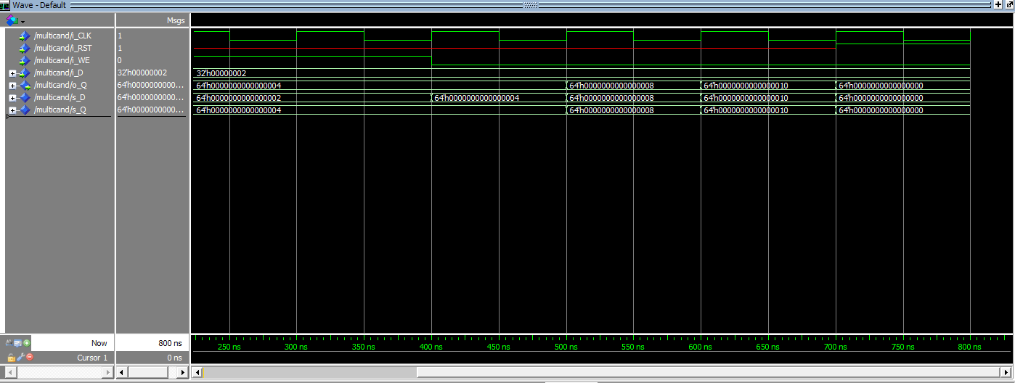
  - **** Each of the screen shots are loading, shifting, then reseting
- Explain how you implemented the left-shift operation
  - I used the & operation to add a zero to the end.

- [Part 3] Multiplier (2 pts)
- Attach waveform screenshots for loading, reset, and right-shifting
  - Loading
  - Reset
  - Right-shifting
  - 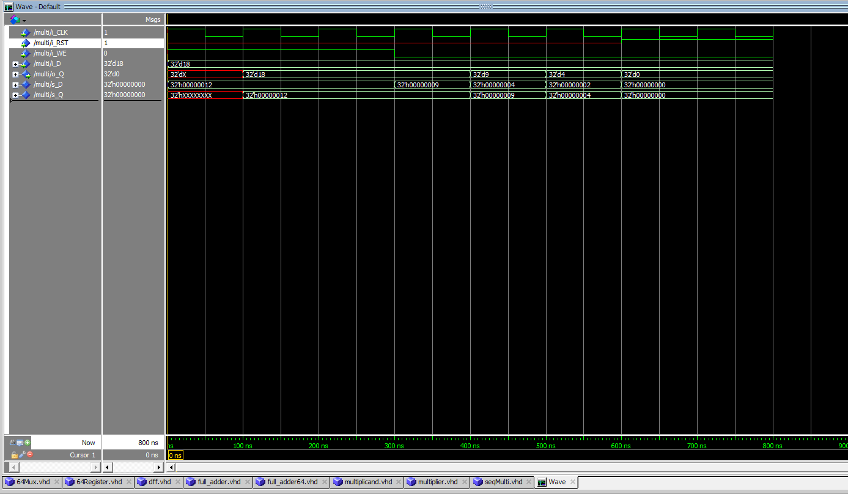
  - **** Each of the screen shots are loading, shifting, then reseting

- Explain how you implemented the right-shift operation
  - I used the & operation to add a 0 to the front of the data.

- [Part 4] 64-bit ALU (2 pts)
- Attach waveform screenshots for multiple test cases.
- Describe which method you choose to implement 64b ALU
  - 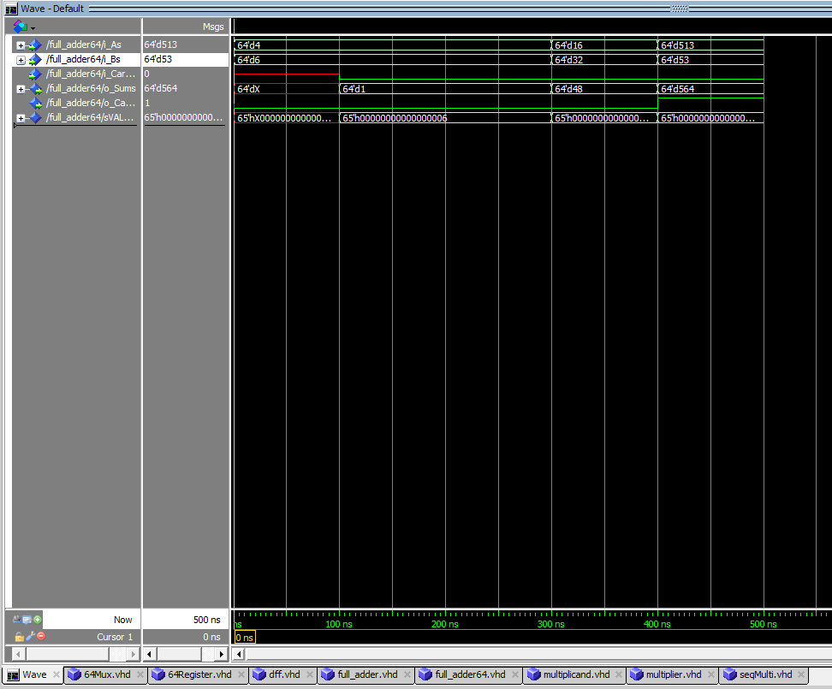
  - I used the full adder from a previous lab and just used for generate to add all 64 bits.

- [Part 3] Sequential multiplier (4 pts)
- Attach waveform screenshots for multiple test cases
- 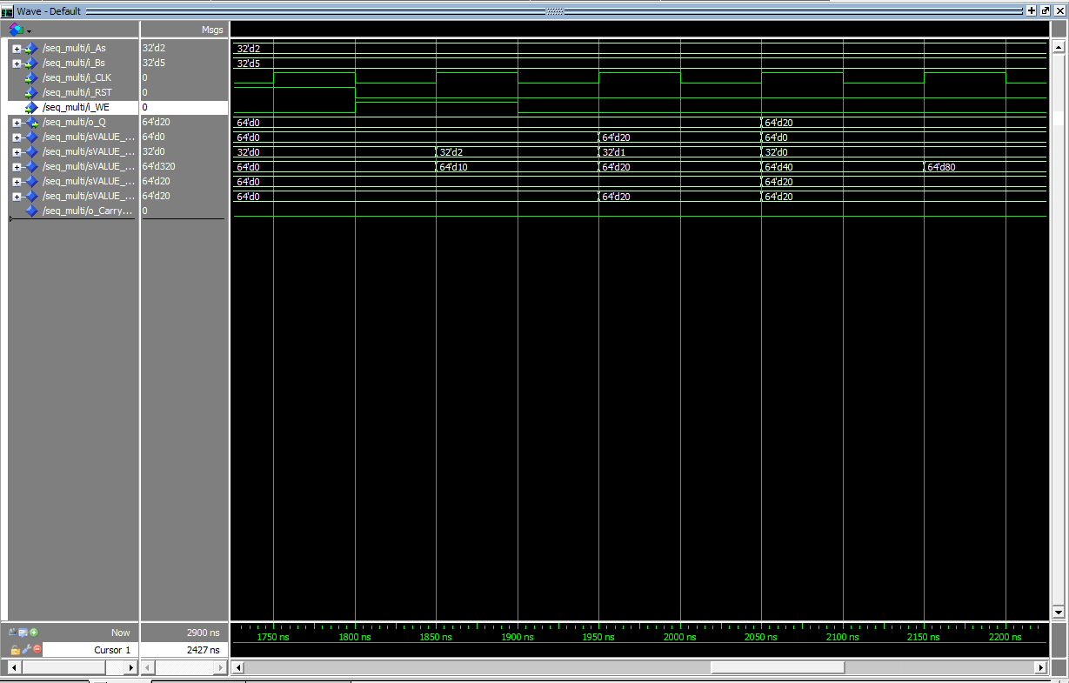
- Doesn’t work completely took partial credit
- Attach a screenshot of the schematic or diagram
  - 